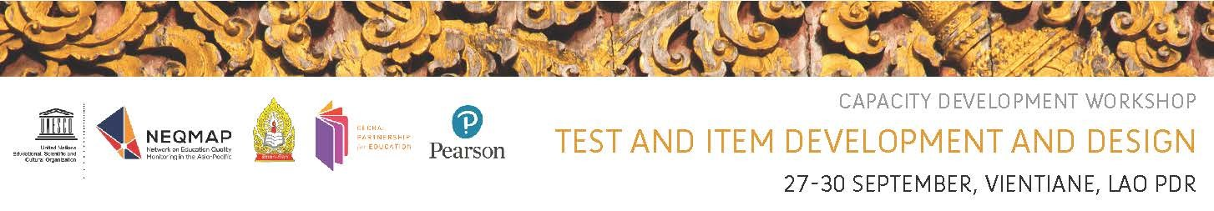

**List of Participants**

|  |  |
| --- | --- |
| **Ministry of Education and Sports** | |
| 1. Ovilouth Souksavat (Mr.) | Lao National Commission for UNESCO | |
| 2. Somboun Masouvanh (Mr.) | Lao National Commission for UNESCO | |
| 3. Singsavipha Sonephanh (Ms.) | Technical Vocational Education Department | |
| 4. Pakaythong Souksengchanh (Mr.) | Technical Vocational Education Department | |
| 5. Khammai Sivongxay (Ms.) | Department of Teacher Education | |
| 6. Valor Boualongxaifasao (Mr.) | Department of Teacher Education | |
| 7. Anita Vannasouk (Ms.) | Department of Planning | |
| 8. Viengthong Sylathtanavong (Mr.) | Department of Planning | |
| 9. Bounhieng Singvongsa (Mrs.) | Department of Preschool and Primary Education | |
| 10. Dasavanh Phonasa (Mrs.) | Department of Preschool and Primary Education | |
| 11. Bounthanome Chanthavone (Mrs.) | Department of Preschool and Primary Education | |
| 12. Manosinh Masavongdy (Mr.) | Department of Secondary Education | |
| 13. Venpheth Sisoulath (Mrs.) | Department of Secondary Education | |
| 14. Songka Keochansy (Mr.) | Department of Secondary Education | |

|  |  |
| --- | --- |
| **Education Quality Assurance Center** | |
| 15. Vanhsay Noraseng (Mr.) | Director | |
| 16. Panya Chanthavong (Mr.) | Deputy Director | |
| 17. Viengsay Soulachit (Mr.) | Testing Evaluation Division | |
| 18. Bongdouangchanh Pormoua (Mr.) | Testing Evaluation Division | |
| 19. Phoukhaokham Souvanh (Mrs.) | Basic Education Assurance Division | |
| 20. Khamdy Phanisvong (Mr.) | Testing Evaluation Division | |
| 21. Viengsavanh Keota (Mrs.) | Administration division | |
| 22. Wathanar Pommalungsi (Mr.) | Testing Evaluation Division | |
| 23. Kingsanga Nhoysaikham (Mrs.) | Testing Evaluation Division | |
| 24. Khinnithuck Sengbandith (Mr.) | National Quality Framework | |
| 25. Kongma Vongsengchanh (Mr.) | Administration division | |
| 26. Soubaki Vongsettha (Mr.) | Basic Education Assurance Division | |
| 27. Oleluck Somoulay (Ms.) | Basic Education Assurance Division | |

|  |
| --- |
| **Research Institute of Education Science** |

28. Ding Chanthachak (Mr.)

29. Balo Sibounheuang (Mr.)

|  |
| --- |
| **Vientiane Capital Education and Sport Service** |

30. Phetsalay Keophilavong (Mr.)

31. Bounthanh Sengmany (Mr.)

|  |
| --- |
| **Teacher College** |

32. Phongsavath Silipanya (Mr.)

|  |
| --- |
| **ICT Center for Education and Sport** |

1. Syphone Phimmajack (Mr.)

|  |  |
| --- | --- |
| **Partner Organizations** | |
| 34. David Wesley Leach (Mr.) | Vice President International Programmes, Pearson | |
| 35. Sohee Won (Ms.) | UNICEF Lao PDR | |
| 36. Phillip Belling (Mr.) | Basic Education Quality and Access in Lao PDR | |
| **UNESCO Bangkok** | |
| 37. Ramya Vivekanandan Rodrigues (Ms.) | Section for Inclusive Quality Education | |
| 38. Tserennadmid Nyamkhuu (Ms.) | Section for Inclusive Quality Education | |
| 39. Payal Goundar (Ms.) | Section for Inclusive Quality Education | |
|  |  | |